Venn Diagrams and Tables
Venn Diagrams
Two circle diagrams:
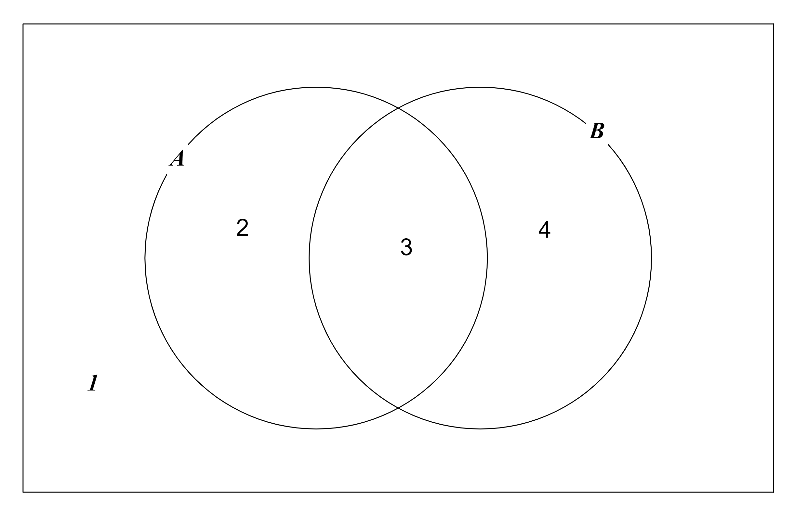

Let’s talk about regions inside this rectangle.
is the region inside the A circle regions 2 and 3
is the region not inside the A circle regions 1 and 4
is the region inside both the A circle and the B circle region 3
is the region inside either the A circle or the B circle (or both) regions 2, 3 and 4
etc
Example 1
regions 2 and 3
regions 1 and 2
region 2

Example 2
regions 1 and 4
regions 3 and 4
regions 1,3 and 4

Example 3
region 3
regions 1, 2 and 4

Example 4
regions 1 and 4
regions 1 and 2
regions 1,2 and 4

Nowandare both regions 1,2 and 4
We say

Three circle diagrams:
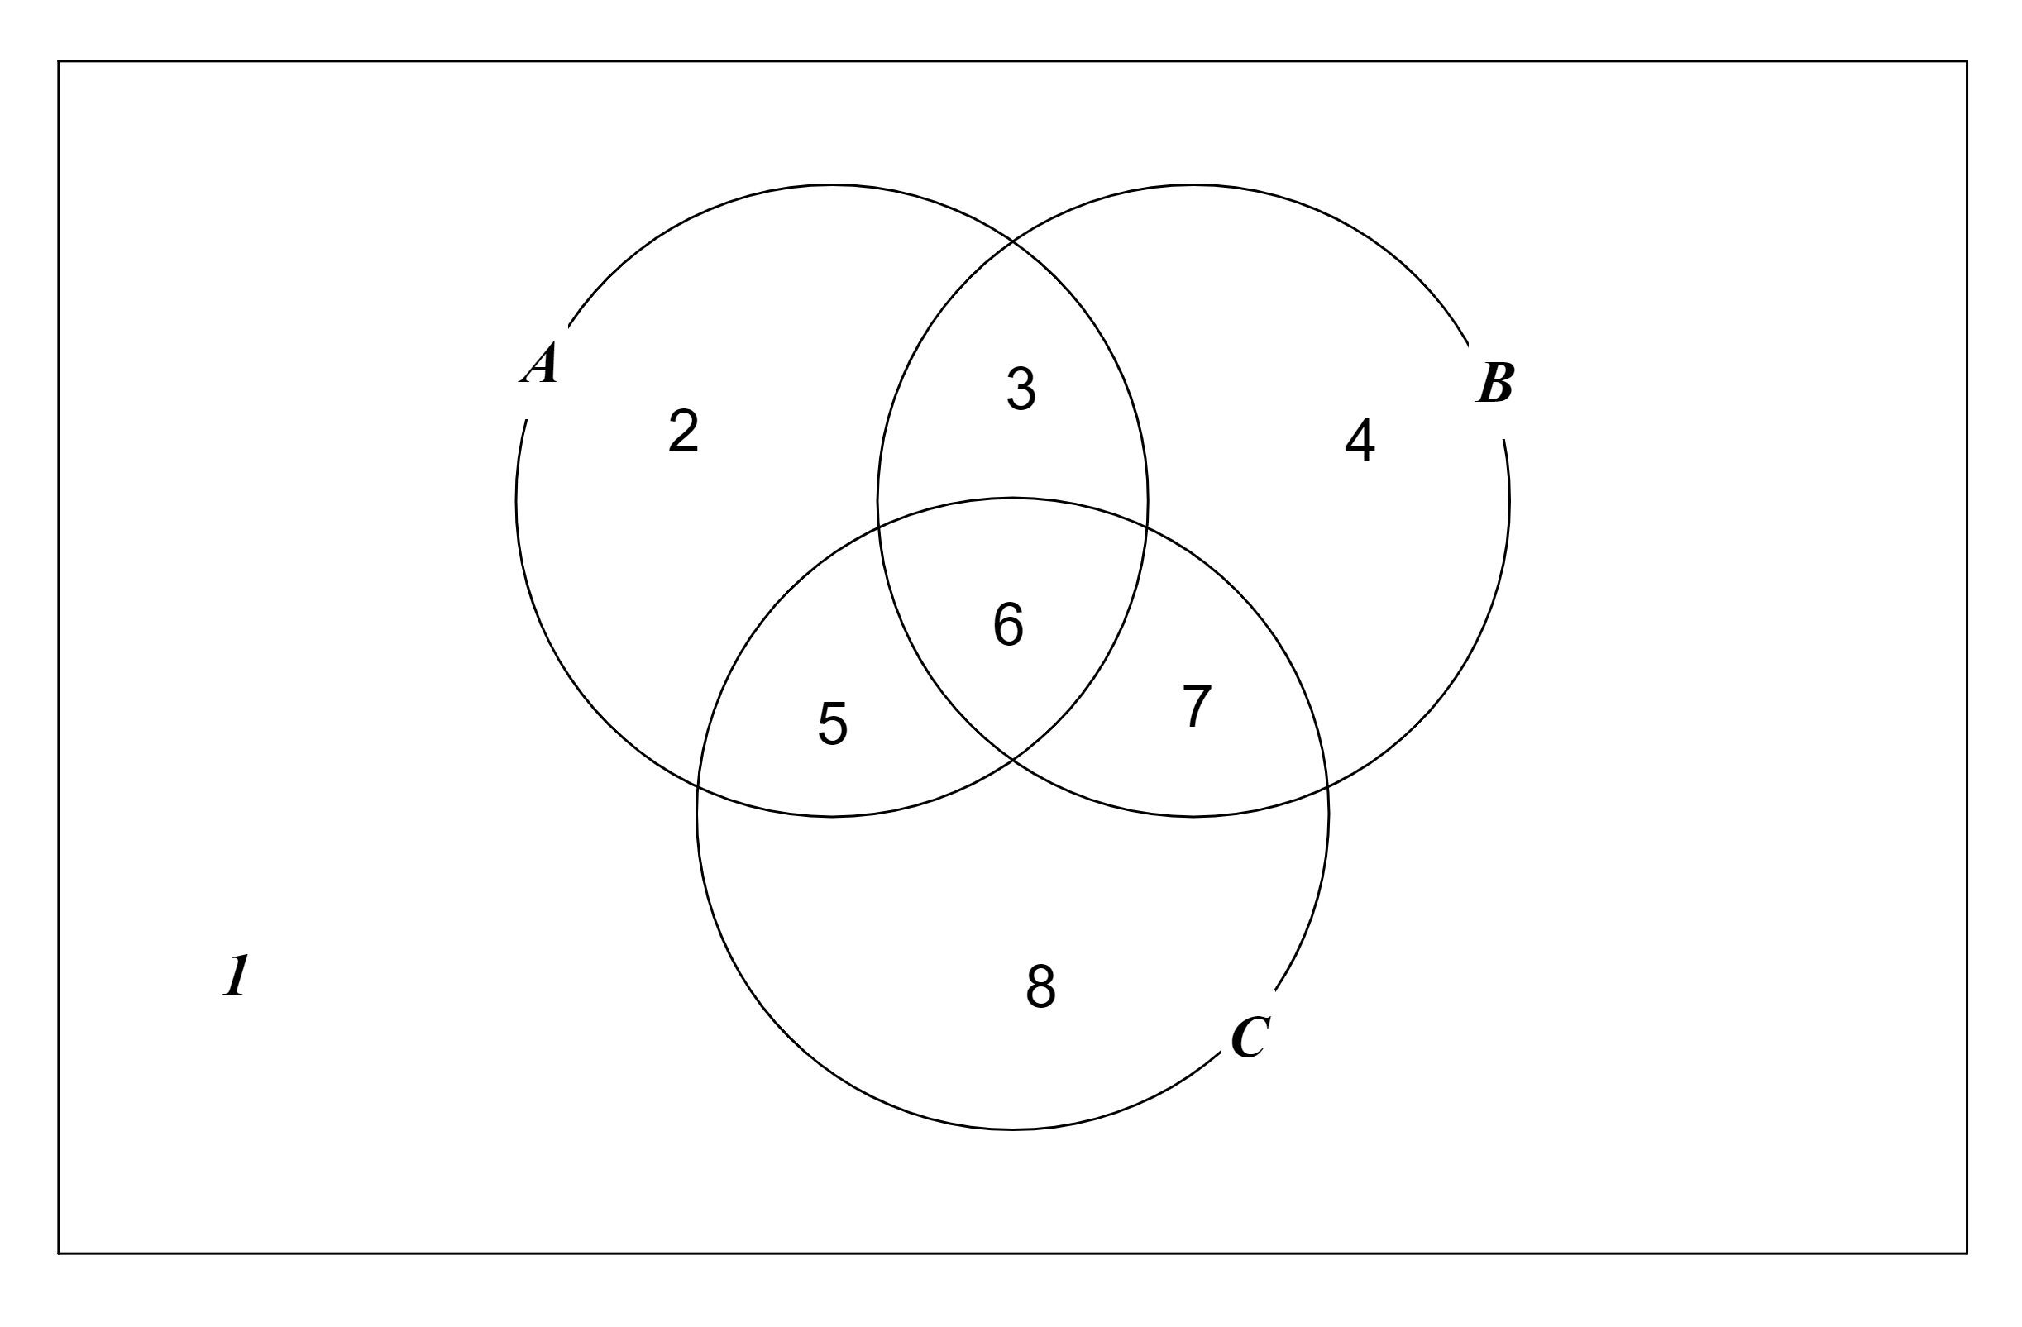

Let’s talk about regions inside this rectangle.
Example 5
regions 3 and 6
regions 5, 6, 7, 8
region 6

Example 6
regions 2, 3, 4, 5, 6, 7
regions 2, 3, 5, 6, 7, 8
regions 2,3,5,6, 7

Example 7
regions 3, 6
regions 5, 6
regions 3, 5, 6

Example 8
regions 3, 4, 5, 6, 7, 8
regions 2, 3, 5, 6
regions 3, 5, 6

Now
andare both regions 3, 5, 6
We say

Let 1 denote the whole region inside the rectangle, that is regions 1, 2, 3, 4, 5, 6, 7, 8
Let 0 denote no region. So:
regions 2, 3, 5, 6 so
regions 1, 2, 3, 4, 5, 6, 7, 8 so
no region so
regions 2, 3, 5, 6 so

Use Venn diagrams to prove the following rules: (no need to do them all)

You will have noticed that we have the same rules for Propositions, Switching Circuits and Venn Diagrams (with slightly different notation). This means that we can use Venn diagrams to simplify expressions arising from propositions or switching circuits.

Propositions
We can use a Venn diagram to show that:
And this shows that:

Switching circuits
We can use a Venn diagram to show that:
And this shows that:

see EXERCISE 1

Tables
We can also use tables to simplify expressions arising from propositions or switching circuits.
Let’s use the notation we had for switching circuits. (We could equally well use the notation we had for propositions)

Here is a table for two variables. The cell marked * represents
*

Here is another table. The cells marked * together represent
*
*

But:

So the cells marked * together represent
etc

Example 1
Simplify:
We mark the cells
 | * | *

The * occupy all thecells.
So:

We could do this using the rules:

Example 2
Simplify:
We mark the cells
 |  | *
 | * | *

The * occupy all thecells and all thecells.
So:

Wait a minute. Haven’t we counted thecell twice?
Yes we have and it’s OK.
You will recall that:
so
So:

=
=
=

Here is a table for three variables. The cell marked * represents
*

etc
Example 3
Simplify
We mark the cells
*
*

The * occupy all thecells
So:

Example 4
Simplify
We mark the cells
 |  | * | *
 |  |  | *

The * occupy all thecells and all thecells
So:

We can further simplify this to:

Example 5
Simplify
We mark the cells

 | * | * | * | *

The * occupy all thecells
So:

Example 6
Simplify
We mark the cells
 | * | * | * | *
 |  | * | *

The * occupy all thecells and all thecells.
So:

Example 7
Simplify
We mark the cells

 | * | * | *
 | * | * | *

The * occupy all thecells and all thecells.
So:

Example 8
Simplify
We mark the cells

 |  | * | *
 |  | * | *
 |  | * | *

The * occupy all thecells and all thecells
So:

We can further simplify this to:

We have used Venn diagrams and tables to simplify expressions. Instead we could bash through the algebra.
Example

=
=
=
=
=
=
I think I prefer to use Venn diagrams and tables.

EXERCISE 1
1)
Use a Venn diagram to show:

So the circuit:

is equivalent to circuit:

We have a circuit. We write down a mathematical expression to describe this circuit. We simplify this expression using a Venn diagram. We redesign our circuit using fewer switches.
How cool is that?
2)
Use a Venn diagram to show:

So circuit:

is equivalent to a single switch
3)
Re-do question (1) using a table.
4)
Re-do question (2) using a table.

EXERCISE 2

Simplify the following, using tables.
1)

2)

3)

4)

SOLUTIONS 1
1)
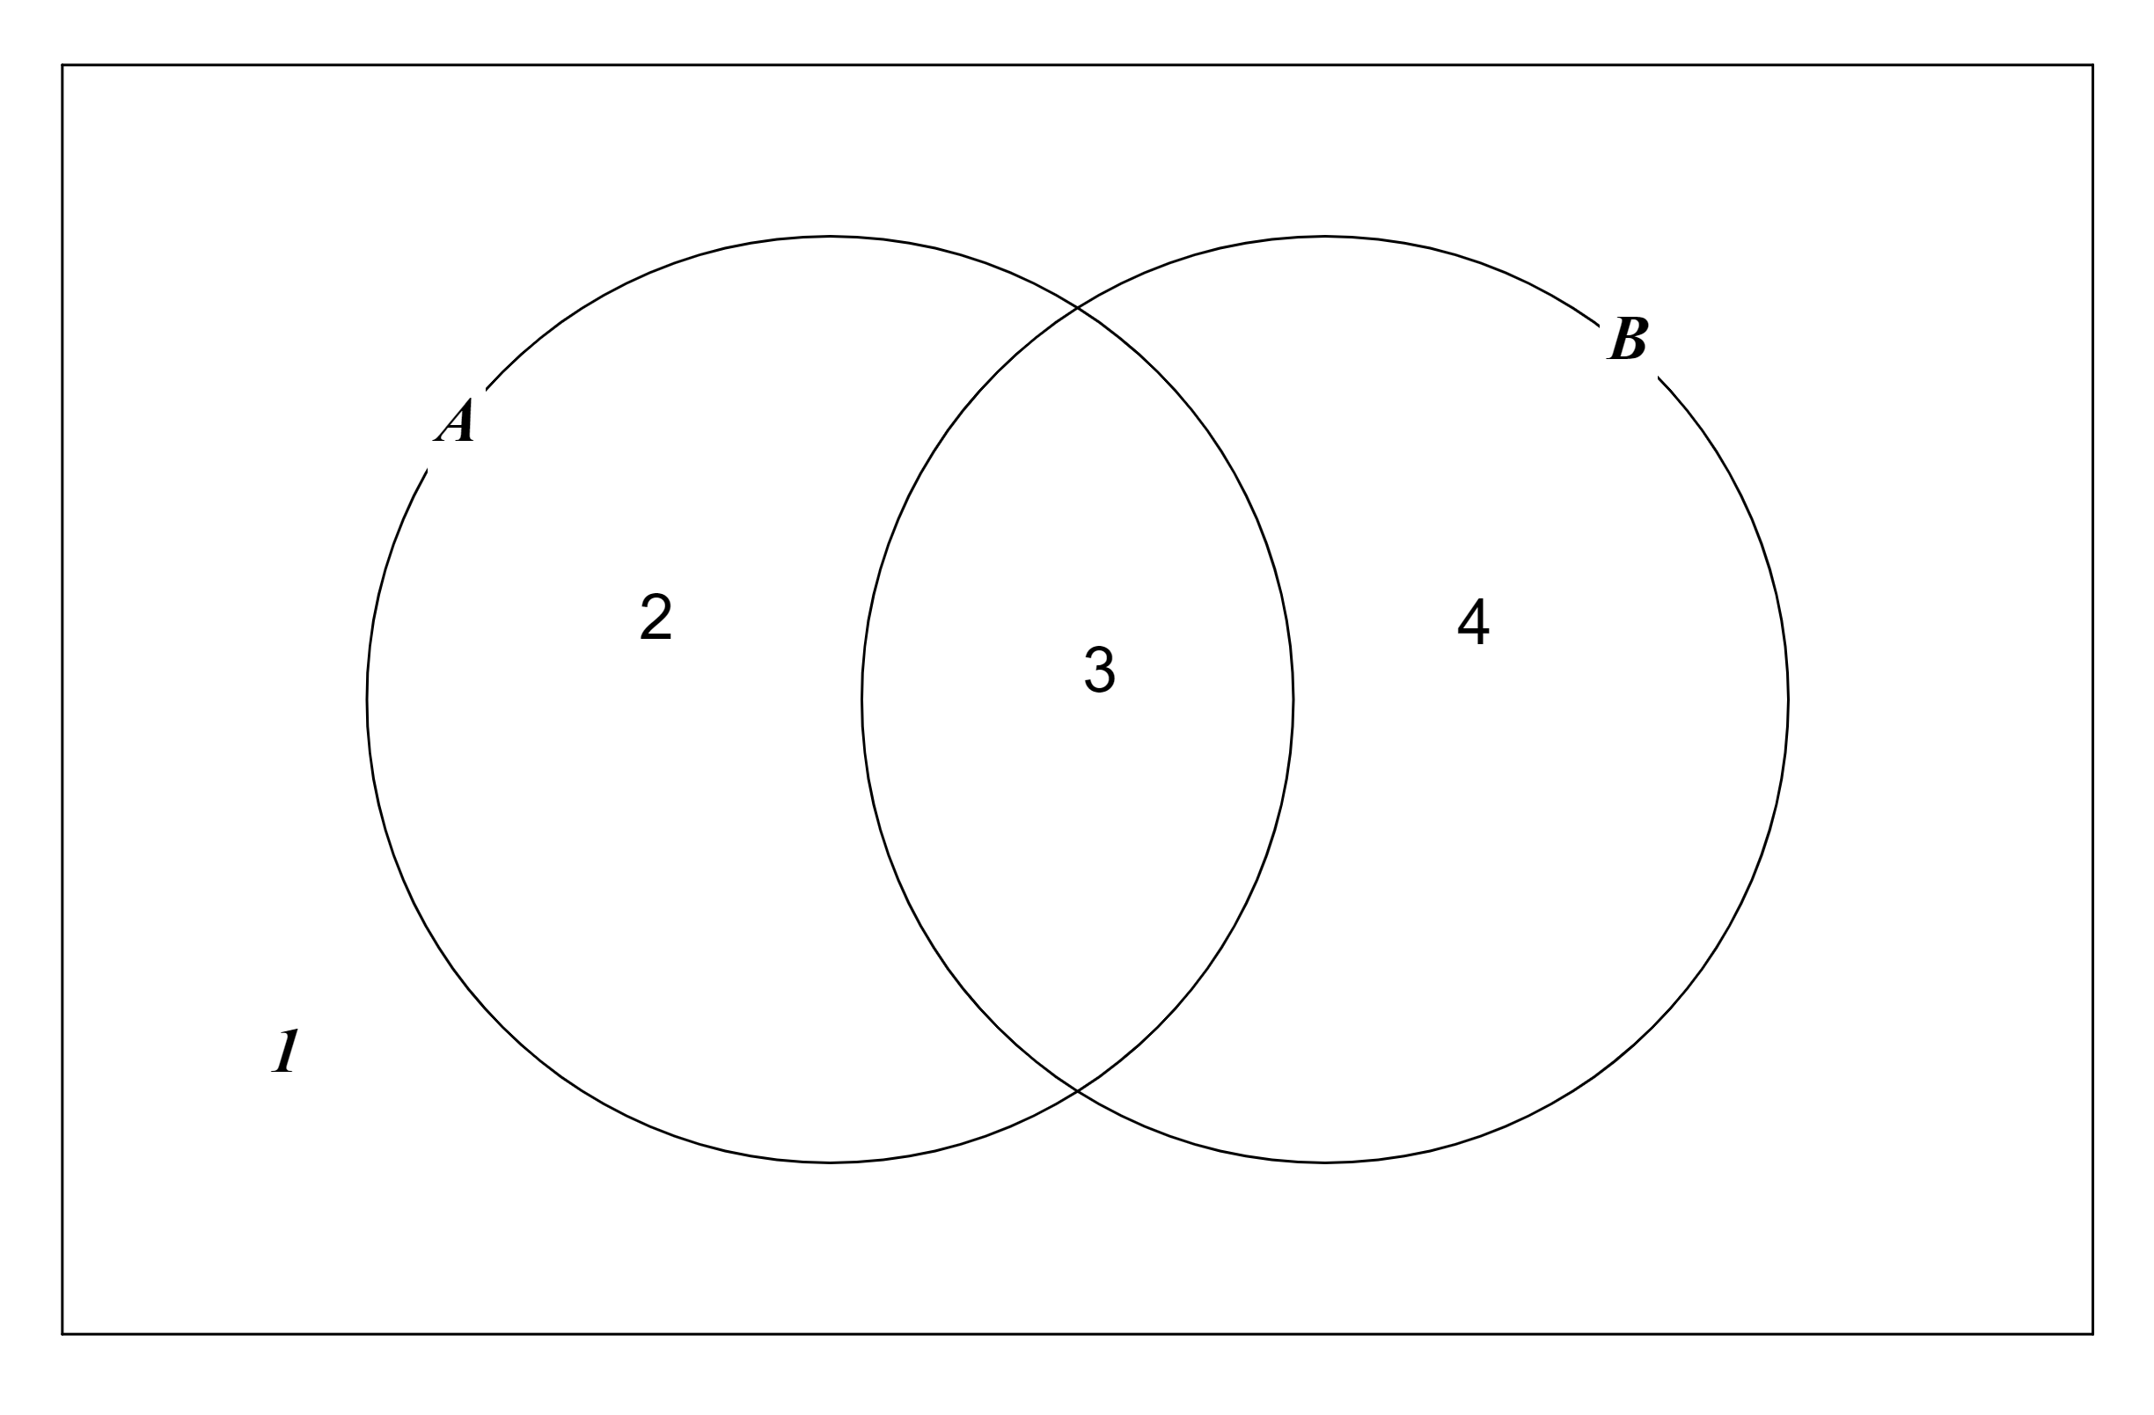

region 3
region 2
region 1
regions 1, 2, 3
and
regions 1, 2, 3

2)
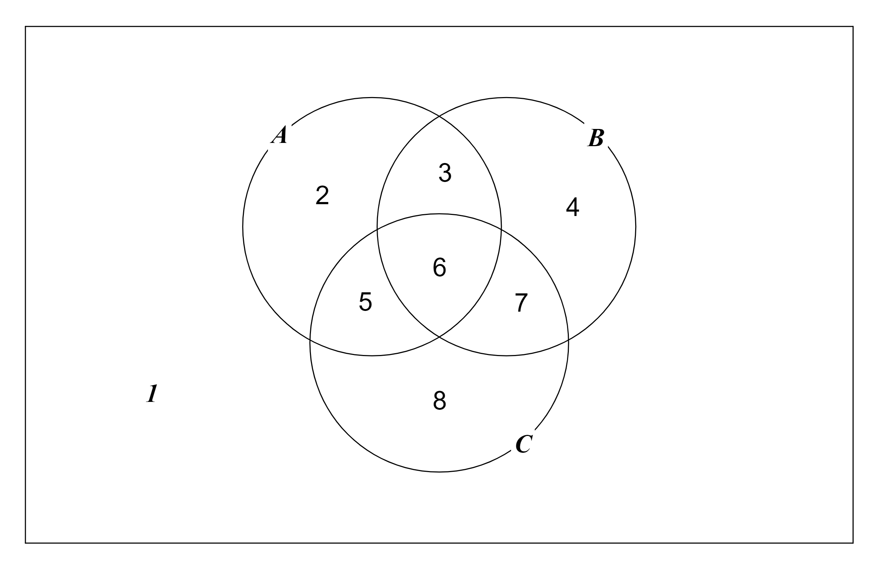

region 6
region 3
region 5
region 2
regions 2, 3, 5, 6
and
regions 2, 3, 5, 6

3)

 | *
 | * | *

4)

 | * | *
 | * | *

SOLUTIONS 2
1)

 | * | *

Simplifies to

2)
 | *
 | * | *

Simplifies to

3)
 |  | * | *
 |  | * | *

Simplifies to

4)
 | * |  | * | *
 | * |  | *

Simplifies to

Which further simplifies to:

